**Project Title:-Web based Electricity Billing System**

**Department of Computer Science**

**College of Computing**

**Selected topics in computer Science**

**SUBMITTED BY**

1. **ABEBU BASHAW …………….. …………………………….……1752/11**
2. **DANIEL WERKAYEHU …………………………………………….1832/11**
3. **LAMESGIN NGUSSIE …...……………………………………….….1671/11**
4. **YARED BIRHANE……………………………………………………1803/11**
5. **HABTEWOLD MULUALEM…………………………………………1215/10**

**Submitted to: Chalew T.**

Contents page

1 Introduction 1

2 Objective 1

3 Existing System 1

3.1 Overview 1

3.2 Users/Actors of the system 1

4 Proposed System 3

4.1 Overview 3

4.2 Functional Requirements 3

4.3 Use Case Model 4

4.4 Class Diagram 4

4.5 User Interface mock up 5

4.6 Database Design 7

# Introduction

Our project entitled “Electricity Billing System” aims is to generate bill with all the charges. This project is developed to manage the bill submission process in organization. Manual system that is employed is extremely laborious and quite inadequate. It only makes the process more difficult and hard. The aim of our project is to develop a system that is meant to partially computerize the work performed in the Electricity Board like generating monthly electricity bill, record of consuming unit of energy, Store record of the customer and previous unpaid record. Using this system user can submit their bill online and check the status of their bill. In this system employee can submit their bill to their manager online. After submitting the bill concerned manager gets the notification. Manager review the bill and approve the bill or disapprove. Employee can check the status of the bill any time after login the system. Employee can submit bill of various amount. An email will be sent to the concerned people to let them know about the status of the bill. The main propose of this bill management system project is developing a system that automate the bill submission and bill approval task. In big organization bill submission is very tiresome work and maintaining the record of bill is very difficult and time consuming. In present system, user have to work manually to maintain bill records and it is very difficult to know the status of the submitted bill. To overcome this entire problem we have developed this bill management system.

# Objective

➢ the objective of this project is to develop a computerized system that manages Electricity power billing system

# Existing System

## Overview

The old manual system was suffering from a series of drawbacks. Since whole of the system was to be maintained with hands the process of keeping, maintaining and retrieving the information was very Tedious and lengthy. The records were never used to be in a systematic

Order. There used to be lots of difficulties in associating any particular transaction with a particular context. If any information was to beFound it was required to go through the different registers document .There would never exist anything like report generation. There would

Always be unnecessary consumption of time while entering records and retrieving records. One more problem was that it was very difficult to find errors while entering the records. Once the records were entered it was very difficult to update these records. In present, work done in the electricity board is performed in computerized system but this system not localizes and high cost .works only in English language which is great problem for the department. For this reason we have add localization to the existing system. So the proposed system helps to use in Amharic language and decrease the cost to buy the existing system.

## Users/Actors of the system

1. **Customer:** someone who want to access the service.

* View service status
* Pay bill
* Download bill

1. **Administrator:** users of the system who can control access right for other users.

* Create new account
* Change password
* Deactivate employee
* Activate employee
* View report

1. **Employee:** is a person who controls bill information.

* Generate monthly report
* View bill information
* View user’s information
* Add news
* Delete news

# Proposed System

## Overview

During our observation and interview of users we have observed certain problems from the manual based system; the general overview of our proposed system is to address the problem of the existing manual system of electric power bill. The proposed system solves those entire problems in the existing system. Because the system is very integrated and it controls all the data input and error which happened during filling any forms whether during bill information registration or any other actions. The new system will be able to access and retrieve different data effectively and efficiently.

The proposed system will be able to:

* Reduce wastage of time
* Retrieve bill information from the database
* Update the bill information
* Give data availability
* Generate the report within needed time.
* Facilitate the activity of the organization.
* Easy to use (user friendly).
* Reduce the need of paper

.

## Functional Requirements

A functional requirement specifies what the proposed system should do. And describe the interactions between the system and its environment. For example, functional requirement of our system is must assign customer bill account and make accessible for a user, allow the employees to manage data easily and allow the administrator to control account. The main requirement that used to handle are observable tasks or processes that must be performed by the system:

* Make accessible interface for system user
* Assign new customers to the system
* Generate report at any time
* Allow the customer to follow their bill information at any time and everywhere.
* Allow the customer to send their complaints
* Allow the employee to view customer’s complaint
* Allow the administrator to create account for employees
* Allow system users to change their passwords

## Use Case Model

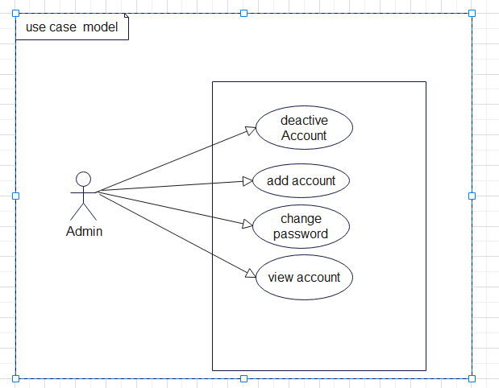

*Figure 1: Use case diagram*

## Class Diagram

Class are the basic components of any object oriented software system and UML class diagrams provide an easy way to represent the system. As well as showing individual classes, in detail, class diagrams show multiple classes and how they are related to each other.

A class consists of: -

* A unique name (conventionally starting with an uppercase letter)
* A list of attributes (int, double, Boolean, string etc.)
* A list of methods.

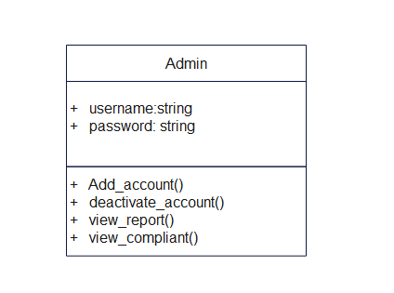

*Figure 2: class diagram*

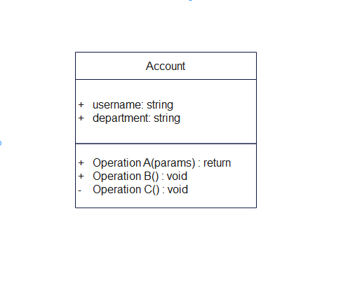

## User Interface mock up

User interface prototyping is an iterative analysis technique in which users are actively involved in the making-up of the user interface for a system. It enables to explore the problem domain and the solution space of the system. It is all about modelling the system before the actual

Implementation. It helps the User interface designers cross-check with the user’s expected functions and gets the user’s feedback on whether the system model is appropriate.

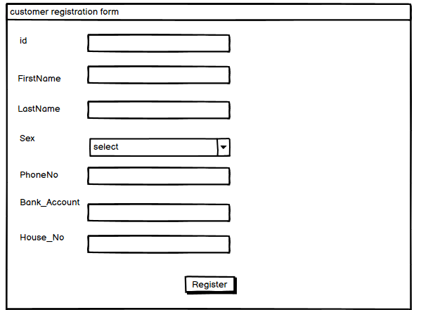

## Database Design

Physical database design translates the logical data model into a set of SQL statements that define the database. For relational database systems, it is relatively easy to translate from a logical data model into a physical database. Rules for translation:

* Entities become tables in the physical database.
* Attributes become columns in the physical database. Choose appropriate data type for each of the columns.
* Unique identifiers are not allowed to have NULL values

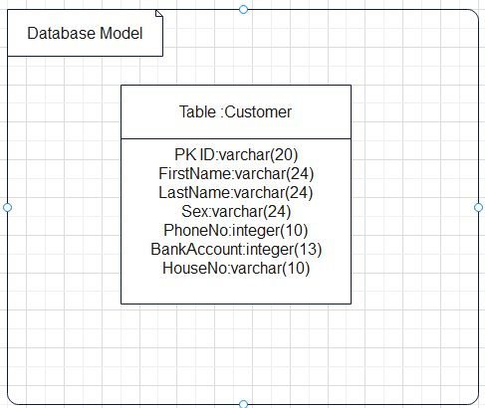.

*Figure 3: database diagram*